Usage Statistics for snydersstoughton.com
Summary Period: Last 12 Months
Generated 11-Jan-2010 01:27 EST

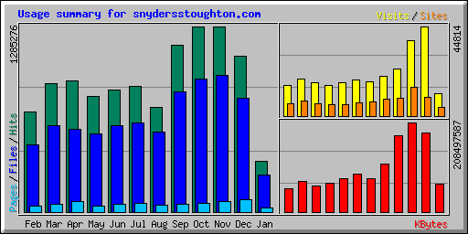
Summary by Month
Month | Daily Avg |  |  |  | Monthly Totals
Month | Hits | Files | Pages | Visits | Sites | KBytes | Visits | Pages | Files | Hits
Jan 2010 | 31981 | 23409 | 2553 | 1006 | 4322 | 65331578 | 11072 | 28093 | 257500 | 351791
Dec 2009 | 34908 | 25328 | 2791 | 1445 | 9244 | 183659700 | 44814 | 86547 | 785196 | 1082160
Nov 2009 | 42651 | 31474 | 2510 | 1258 | 14602 | 208497587 | 37747 | 75300 | 944222 | 1279533
Oct 2009 | 41460 | 29712 | 1894 | 752 | 9102 | 178337175 | 23324 | 58744 | 921087 | 1285276
Sep 2009 | 38445 | 27850 | 1829 | 655 | 8529 | 111814873 | 19673 | 54891 | 835512 | 1153367
Aug 2009 | 23383 | 17787 | 1510 | 556 | 7145 | 78233999 | 17245 | 46813 | 551409 | 724874
Jul 2009 | 28009 | 19969 | 2001 | 588 | 6635 | 88433564 | 18242 | 62060 | 619055 | 868283
Jun 2009 | 28255 | 20039 | 1717 | 557 | 5889 | 77617336 | 16723 | 51532 | 601175 | 847664
May 2009 | 25912 | 17498 | 1284 | 489 | 5644 | 67135667 | 15187 | 39823 | 542454 | 803277
Apr 2009 | 30265 | 19052 | 2481 | 555 | 6066 | 60482274 | 16660 | 74450 | 571573 | 907963
Mar 2009 | 28633 | 19299 | 1731 | 591 | 7479 | 72232841 | 18335 | 53662 | 598272 | 887653
Feb 2009 | 24733 | 16679 | 1458 | 541 | 6225 | 53205707 | 15159 | 40840 | 467030 | 692548
Totals |  |  |  |  |  | 1244982301 | 254181 | 672755 | 7694485 | 10884389

Generated by Webalizer Version 2.01

